Chemistry 31 N. Martel
Unit 14: Kinetics and Equilibrium
[NOTE: Depending on the year, some or all of this unit may be omitted.]

Vocabulary:
Chemical kinetics
Reaction mechanism
Effective collisions
Collision theory
Activation energy
Activated complex
Catalyst
Rate law
Rate order
Rate determining step
Reversible reaction
Dynamic equilibrium
Equilibrium constant
Homogenous equilibrium
Heterogeneous equilibrium
Reaction quotient
Solubility product constant
Common ion effect
Le Chatelier’s principle

Intro to Kinetics and Reaction Rates
Chemical kinetics = study of speeds/rates of chemical reactions and the mechanisms by which reactions occur

Reaction mechanism = sequence of steps by which reactions occur

-Usually look at rates in terms of how much reactant turns into products over a specific time period

How do reactions happen?
-Particles must collide to react
-Could collide but not react, so in order to react need “effective” collisions
-Effective collisions are defined by two conditions:
1. Enough energy to break bonds and form new ones
2. Exactly the right orientation to react (head on collision is best)
-Activation energy (E_{a}) = minimum amount of energy required for reaction
-Activated complex = high energy transition state, momentary arrangement of particles– reaction could go either way

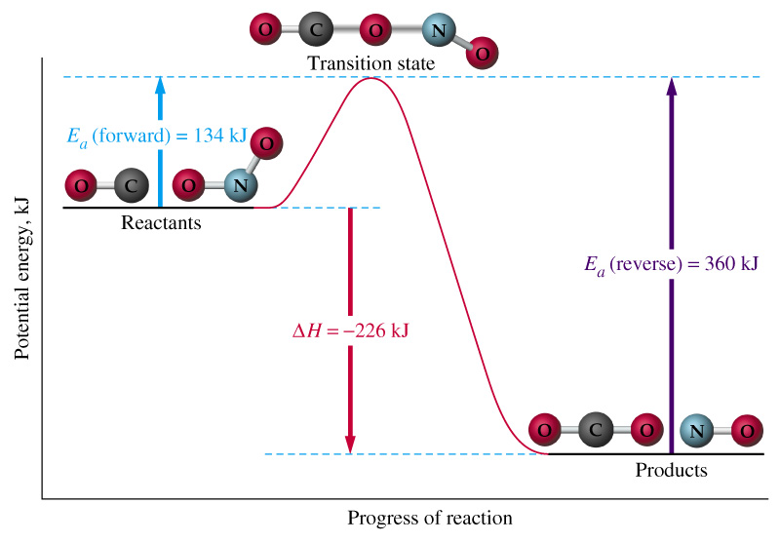
Note: to distinguish between them, use E_{F} to mean the activation energy of the forward reaction and E_{R} to mean the activation energy of the reverse reaction
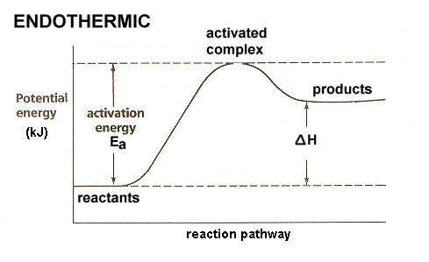
SO….. E_{F} = E_{R} + ∆H (don’t memorize… learn the graph!)
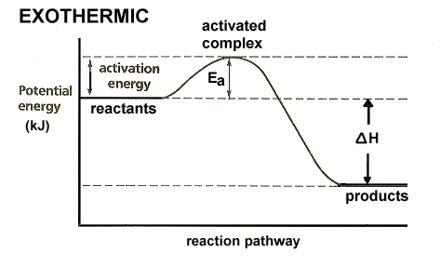
SO…..E_{R} = E_{F} + ∆H (don’t memorize… learn the graph!)

Make sure you understand and can label these graphs (reactants, products, activated complex, heat of reaction, activation energy, heat of reactants, heat of products, energy of activated complex, for forward and reverse reactions… etc.)

Now, how do we make reactions “go” faster?

For any reaction to “go” faster- need more effective collisions…

Four Factors that Influence Rates of Reactions
1) Temperature – A 10 deg Celsius increase in temperature causes a double rate for most reactions
2) Concentration
3) Catalyst
4) Nature of reactants

Temperature

Graph:

At a higher temperature, there are more effective collisions – more molecules have the activation energy needed to react

Concentration

Graph

More molecules have activation energy needed to react

Catalyst

Catalyst = substance that lowers the activation energy by supplying an alternate route by which chemical reaction occurs (not known exactly how, but it does)

Graph

More molecules have activation energy needed to react (noticing a theme here??)

Nature of reactants

Weak bonds = easier to break, reactants with weak bonds will react faster
Strong bonds = harder to break, reactants with strong bonds will react slower

Graph

Specific Rate Laws

Rate law – shows how the rate of a reaction depends on the concentration of reactants

General rate law:

R = k [reactants]ª

Where…

R = rate of reaction, usually in M/time (in other words, mol/(L x time))
k = specific rate constant, in L^{b}/(mol^{b} x time) where b is overall rate order – 1
[ ] means concentration
[reactants] = concentration of the reactants in M (mol/L)
a = rate order (a = 0 means “zeroth order”, a = 1 “first order”, a = 2 “second order”)

If we determine the rate order in each reactant, we can sum those to determine the overall reaction rate order (example shortly)

We can determine the specific rate law for a reaction 3 ways:
1. Experimental data (now)
2. Chemical mechanism (later)
3. Graphing techniques (AP & beyond)

Example:
Given the reaction: 3W + 2X + Y → 4D and the data below, determine the rate law and overall order of the reaction

Experiment # | [W] in M | [X] in M | [Y] in M | Rate of formation of product D in M/sec
1 | .01 | .01 | .01 | 2
2 | .02 | .01 | .01 | 4
3 | .01 | .03 | .01 | 18
4 | .01 | .03 | .06 | 18

Find the specific rate law, the rate constant k…..

We also might be asked to find the instantaneous rate of the reaction if we are given the concentrations of the reactants… so for instance, if [W] = .04, [X] = 0.02, and [Y] = 0.01 M, what is the instantaneous rate of the reaction?

Reaction Mechanisms
Mechanism = sequence of steps by which a reaction occurs

Ex: for the overall reaction: H₂ + Cl₂ → 2 HCl might expect a simple mechanism (drawing)

In reality, it has been determined (through elaborate experiments) that the actual mechanism is as follows:

Cl₂ + UV photon → 2 Cl· (slow)
Cl· + H₂ → HCl + H· (fast) where H· is a free radical (contains an
unpaired electron)
Cl· + H· → HCl (fast)

The slow step of a reaction is the rate determining step
Rate law for a reaction is written from the slow step mechanism

R = k[reactants in slow step mechanism]ª where a = their coefficients in the equation for the slow step

In our example, R = k[Cl₂]¹

Intermediate = substance formed in one step in a mechanism and consumed in a later step; intermediates are never included in rate laws (think: which ones are intermediates in our example above?)

If an intermediate appears in the slow step, can use substitution to remove it from the rate law (not something you need to worry about now)

Example:

Overall reaction: 3W + 2X + 3Z → 4D + 2E

Can we get the rate law directly from this alone?

Proposed mechanism:
2W + X → 2D + A (slow)
A + 2Z → D + E (fast)
W + X + Z → D + E (fast)

Addition of all steps in the mechanism must give the overall reaction (check and make sure it does)

Are there any intermediates? If so, what?

Suppose we were given 2 mol W, 2 mol X, 2 mol Z in a 10 L box… considering the reaction and rate law given above….
1. What happens to the reaction rate when the box size is decreased by ½ (final volume of box is 5 L)?
2. What happens to the reaction rate if the concentration of W is doubled?
3. What happens to the reaction rate if the concentration of X is doubled?
4. What happens to the reaction rate if the concentration of Z is doubled?
5. What would adding a catalyst do to the rate?

Intro to Equilibrium
Most reactions are reversible to some extent (under certain conditions can go one way or the other)

A + B ↔ C + D

Imagine if we had A and B (both gases) in a box… what would happen to the rate of the forward and reverse reactions over time?

Graph

Over time, the rate of the forward reaction = the rate of the reverse reaction; this defines equilibrium

At equililibrium, R_{f} = R_{r}

Equilibrium is recognized by constant macroscopic (big, easily visible) properties:
1. Constant temperature
2. Constant color
3. Constant pressure (for gases)
4. Constant concentration

Example: container of water- emptying and filling at the same rate…. looks macroscopically the same, but constantly is getting “new” water

It is useful for us to examine equilibrium mathematically, but we need a way to do it… related to rates/kinetics since at equilibrium R_{f} = R_{r}

Example: hypothetical reaction….

Overall reaction: 2A₂ + 2BC ↔ B₂ + 2A₂C

Mechanism for this reaction:
A₂ + 2BC ↔ B₂ + A₂C₂ (slow)
A₂ + A₂C₂ ↔ 2A₂C (fast)

We could look at the rates of the forward and reverse reactions for each step… and then also isolate constants on one side of the equation and variables on the other… and combine constants by multiplying (a constant times a constant is another constant)… the end result of all this loveliness would be something called an equilibrium constant

End result = equilibrium constant, K_{eq}
Equilibrium expression:
K_{eq} = [products]ª / [reactants]^{b} where [ ] still means concentration in mol/L and a and b are the coefficients of each reactant and product in the equation (sometimes referred to as the Law of Mass Action)

Can practice writing equilibrium expressions, given a reaction…
Examples (on board)…. Haber process for formation of ammonia, formation of HBr from hydrogen gas and bromine liquid, decomposition of calcium carbonate into calcium oxide and carbon dioxide, dissolving of lead(II)chloride

See if you can write the equilibrium expression for each!

NOTE: Solids and pure liquids DO NOT appear in the equilibrium expressions… their concentrations are fixed by their densities (concentration of a solid or pure liquid is density divided by molar mass, and both are constant and can be incorporated in our K without appearing separately in the equilibrium constant expression)

Homogeneous equilibrium = a term used to describe a system where all substances are the same phase
Heterogeneous equilibrium = a term used to describe a system where substances have different phases

Which are homogenous? Which are heterogeneous?

Equilibrium Calculations

Equilibrium constants are determined experimentally (can be looked up based on accumulated data or can be calculated)

K varies with temperature… if the temperature changes, it changes (we won’t worry about how now)… K has NO units!

When K_{eq} is calculated numerically, it has meaning:

K_{eq} Value | Products or Reactants Favored? | Meaning
K_{eq}>>1 | Products favored | Reaction goes to completion
K_{eq} ≈ 1 | Neither favored | Significant amounts of both reactants and products, system is at equilibrium
K_{eq}<<1 | Reactants favored | Hardly any products form

Example of calculating an equilibrium constant:

At 490 degrees Celsius, a 1 L box is found to contain 0.000862 mol hydrogen gas, 0.00263 mol iodine gas, and 0.0102 mol HI gas. Calculate K_{c} (K_{c} is the K_{eq} when dealing with concentrations). (Since the temperature is constant, the system is at equilibrium.)

What does this K value tell us about the reaction??

There are many types of equilibrium calculations… we will cover:
1. Given concentrations, calculate K (done above) (also, given K calculate an unknown concentration)
2. Given some concentrations, calculate others and K (using an “ICE” box)
3. Predicting the direction of a reaction (using reaction quotient)
4. Calculating K using pressures of gases rather than concentrations
5. Solubility equilibrium (using equilibrium constants to predict precipitation)

Using Equilibrium Constants and “ICE” Boxes

What if you don’t know the equilibrium concentrations of everything and you need to determine an equilibrium constant? For instance, if you’re given initial concentrations of the hydrogen and iodine gases and a concentration for the HI at equilibrium, how could you calculate the equilibrium constant?

Strategy:
• Tabulate everything you know in an “ICE” chart (ICE stands for “initial”, “change”, and “equilibrium”)
• Calculate change based on that or using the stoichiometry of the reaction
• Calculate equilibrium concentrations and evaluate K

(Can also rearrange to solve for other quantities once you know the general method)

Example (again using the reaction for formation of HI):
A mixture of .005000 mol hydrogen gas and .01000 mol iodine gas is placed in a 5.000 L container at 448 degrees Celsius and is allowed to come to equilibrium. At equilibrium, the concentration of HI is .00187 M. Calculate K_{c} at 448 degrees Celsius.

First, calculate the initial concentrations of the hydrogen and iodine…

[H₂]_{initial} = .005000 mol/5.000 L = .001000 M
[I₂]_{initial} = .01000 mol/5.000 L = .002000 M

Then, set up your ICE box and fill in what you know:

 | H_{2(g} | I_{2(g)} | 2 HI_{(g)}
I | .001000 M | .002000 M | 0
C
E |  |  | .00187 M

-Think about what the change had to be for the [HI] to end up at .00187 M
-Apply stoichiometry to determine the change in the reactants
-Use that change to find the equilibrium concentrations of the reactants
-Write an equilibrium expression
-Using the equilibrium concentrations you now have, find K

Predicting the Direction of a Reaction

To determine which way a reaction will go, we will use initial concentrations to calculate the reaction quotient and then compare it to the known equilibrium constant.

Reaction quotient (Q) = value determined when initial concentrations are substituted into the equilibrium expression; it can be compared to K_{c}

If Q = K, the system is at equilibrium

If Q<K, the reaction will shift to the right to reach equilibrium, in favor of consuming reactants to form more products

If Q>K, the reaction will shift to the left to reach equilibrium, in favor of consuming products to form more reactants

Example:
If we place a mixture of 2.00 mol hydrogen gas, 1.00 mol nitrogen gas, and 2.00 mol ammonia gas in a 1.00 L container at 472 degrees Celsius, will the nitrogen and hydrogen react to form more ammonia? K_{c} at 472 deg C for formation of ammonia = 0.105.

Calculating K for Gases Using Pressures

When reactants and products are all gases, can formulate the equilibrium constant expression based on their partial pressures rather than concentrations

Looks exactly the same and is done the same way, but instead of using [] for concentration, use P for pressure (and use pressure values when you plug in rather than concentrations)

In this case, we may choose to write K_{p} instead of K_{eq}

Can relate Kp and Kc for gases:

K_{p} = K_{c}(RT)^{∆n} (derived from the ideal gas law) where
R = universal gas constant
T = temperature in Kelvin
∆n = change in number of moles of gas = moles of gaseous product (using coefficients from the equation) – moles of gaseous reactant (using coefficients from the equation)

When ∆n = 0, the number of moles of gas doesn’t change, and K_{p} = K_{c}

Solubility Equilibrium
(one application of equilibrium… will see another application in next unit… acids & bases)

• Example of a heterogenous equilibrium
• Consider dissolving of a substance that is not very soluble (recall precipitate formation and solubility rules)
• When we write the equilibrium expression, we label is K_{sp} (sp means “solubility product”… and you’ll see why when we calculate it)

Ex:
PbCl_{2(s)} ↔ Pb²⁺_{(aq)} + 2 Cl⁻_{(aq)}

K_{sp} = [Pb²⁺][Cl⁻]²

Some definitions/basics to recall and/or keep in mind:
• Solubility = amount that can dissolve, g/L
• Molar solubility of compound = molar amount that can dissolve, mol/L
• Molar concentration of ions = molarity of ions in solution, mol/L
• Solubility product constant K_{sp} = equilibrium constant, no units
• Reaction quotient Q_{sp} = solubility product using non-equilibrium concentrations, no units

Some relationships to know:
• To relate solubility and molar solubility, use molar mass
• To relate molar solubility and molar concentration of ions, use the chemical formula of the compound
• To relate molar concentration of ions and reaction quotient or K_{sp}, use the equilibrium

Examples:
-Determining the K_{sp} from equilibrium concentrations

-Determining solubility from the K_{sp}

-Determining whether precipitation will occur (using the reaction quotient and K_{sp})

Le Chatelier’s Principle

What happens if a system is at equilibrium, and something happens to change/disturb it??

Le Chatelier’s Principle = If a system at equilibrium it disturbed (for instance by a change in temperature, pressure, or concentration), the system (reaction) will shift to counteract the effect of the disturbance

Think about the different types of changes that could be imposed on a system…

Stress Imposed | What Happens to Restore Equilibrium
Increasing concentration of a reactant or product (adding more) | Reaction shifts to consume the “extra”
Decreasing concentration of a reactant or product (removing some) | Reaction shifts to produce more of what was removed
Decreasing volume (for gases) or increasing pressure | Reaction shifts toward lower number of moles of gas
Increasing volume (for gases) or decreasing pressure | Reaction shifts toward higher number of moles of gas
Increasing temperature | Reaction shifts to use up heat (direction will depend on whether the reaction is endothermic or exothermic… think!)
Decreasing temperature | Reaction shifts to produce more heat (direction will depend on whether the reaction is endothermic or exothermic… think!)
Adding a catalyst | No shift, increases the rate of both the forward and reverse reactions
Adding an inert gas | Same effect as increasing the pressure/decreasing the volume

Think of the Haber process (exothermic reaction where nitrogen and hydrogen react to form ammonia)…. What things could be done in a factory to increase the production of ammonia in this reaction?

Textbook Reference:
Chapter 16

